Orders Table:
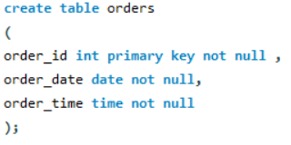
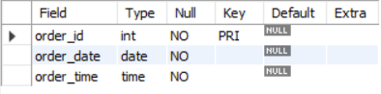

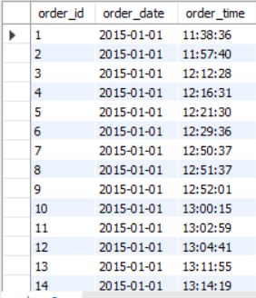

Order_details Table:
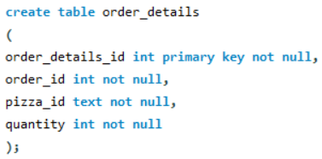
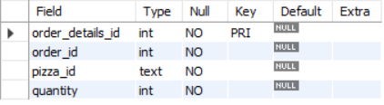

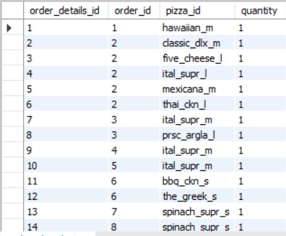

Retrieve total numbers of orders placed.
This helps us see the total volume of orders we handled.
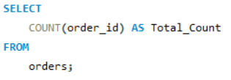
Output:
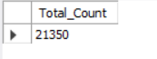

Calculate the total revenue generated from pizza sales.
Calculating the total revenue to see the sales from pizza and its profits.
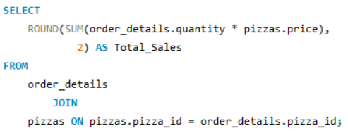
Output:
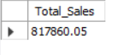

Identify the highest priced pizza.
This identifies our premium pizza and shows our maximum price point.
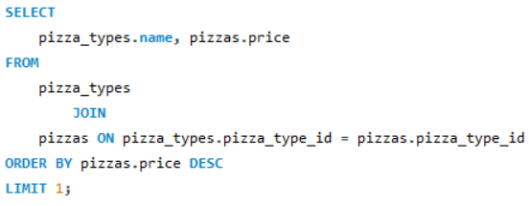
Output:
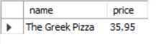

Identify the most common pizza size ordered.
This tells us which size (Small, Medium, Large) is most popular so we can stock enough boxes.
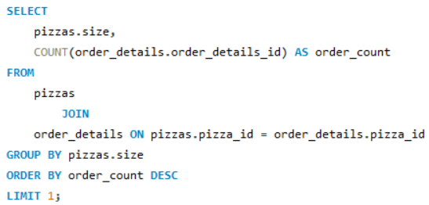
Output:
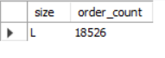

List the top 5 most ordered pizza types along with their quantities.
This identifies our "Best Sellers" so we know which pizzas customers love the most.
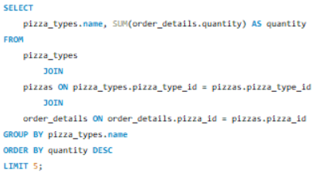
Output:
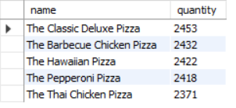

Join the necessary tables to find the total quantity of each pizza category ordered.
We group these to see if customers prefer Veggie, Meat, or other specific styles.
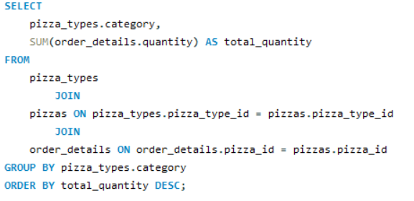
Output:
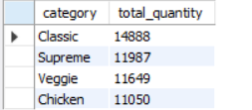

Determine the distribution of orders by hour of the day.
This shows our "Rush Hours" so the shop knows when it needs the most staff.
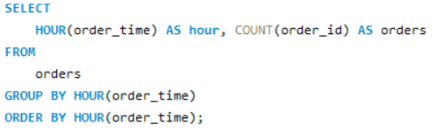
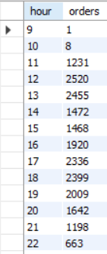

Join the relevant table to find the category wise distribution of pizzas.
This helps us understand the variety and balance of our menu.
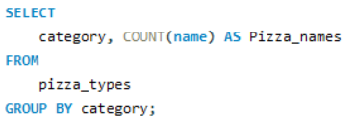
Output:
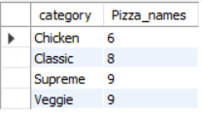

Group the orders of date and calculate the average number of pizzas ordered per day.
This gives us a daily target to aim for and helps with daily food prep.
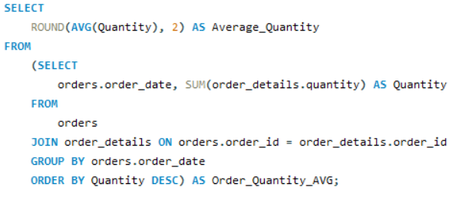
Output:
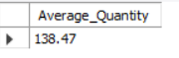

Determine the top 3 most ordered pizza based on the revenue.
Some pizzas sell less but make more money; this identifies our most profitable items.
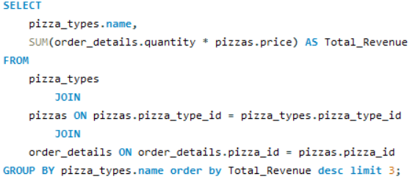
Output:
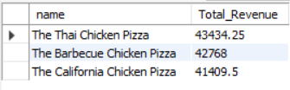

Calculate the percentage contribution of each pizza type of total_revenue.
This shows exactly how much each pizza type helps the business grow financially.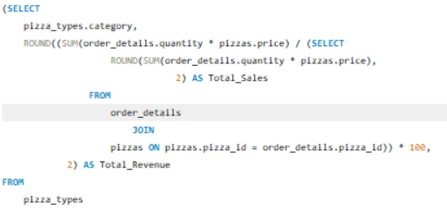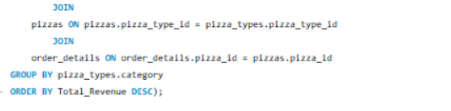
Output:
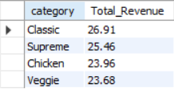

Analyze the cumulative revenue generated over time.
This tracks our growth trend to see if the business is making more money over time
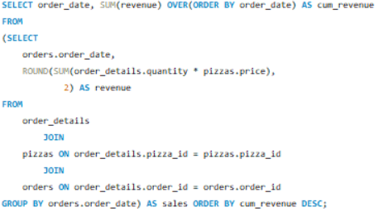
Output:
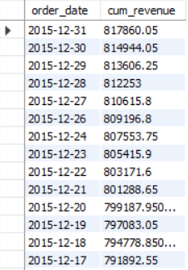

Determine the top 3 most ordered pizza types based on revenue for each pizza category.
This highlights the "Winners" in every single category of our menu.
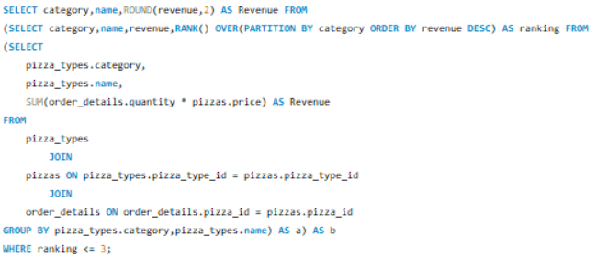
Output:
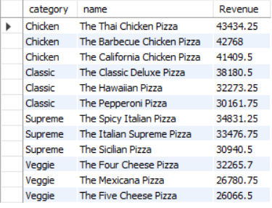

Final Conclusion:
- By identifying the hourly distribution of orders, we found the busiest times of day, allowing for better staff scheduling.
- We noticed the most common pizza size and the top 5 most ordered types, showing exactly what the customers prefer to eat.
- We discovered which specific pizza categories (like Veggie or Meat) and types contribute the most to the total revenue, helping to focus most on these items.
- By calculating the average pizzas sold per day, the shop now has a clear daily performance goal to track its success.

